Does VAR Lead to More Red Cards?
Evidence from a Staggered Difference-in-Differences Design Across Teams in Three Major Top Tier European Football Leagues
Abstract
This paper investigates whether the introduction of the Video Assistant Referee (VAR) leads to a causal increase in the number of red cards given per match. I have used match-level data from 11,475 games across the Bundesliga, Ligue 1, and Premier League from the time period 2014-25, the staggered adoption of VAR in 2017, 2018, and 2019. This acts as a natural experiment. A two-way fixed effects (TWFE) model with home and away team fixed effects and season fixed effects gives a pooled VAR coefficient of +0.014 red cards per match (with SE=0.024, p=0.54), which is consistent in sign but statistically insignificant. Standard errors are clustered at the team level (N=98). Interestingly, heterogeneity analysis revealed opposing league-level effects: VAR is associated with fewer red cards in the Bundesliga and more in Ligue 1, perhaps hinting towards a refereeing culture as a tool to deliver the technology's impact.
1. Introduction
The Video Assistant Referee (VAR) is the most significant regulatory change in modern football. It was introduced to correct clear and obvious errors in goal, penalty, red card, and mistaken identity decisions. However, since its adoption, VAR has led to a strong debate about whether the technology makes the game fairer or disrupts its flow.
This paper focuses on a simple, specific yet measurable outcome: does VAR cause more red cards to be awarded per match? The causal mechanism is direct. VAR allows referees to review serious foul play incidents that may have been missed or misjudged in real time, potentially upgrading yellow cards to red or issuing reds for incidents not originally sanctioned. The overarching policy relevance is that if VAR increases dismissals, it changes not only the competitive balance, but squad planning and the entertainment value of the sport too.
The causal effect is identified by using the staggered introduction of VAR across three leagues as a natural experiment: Bundesliga had it first formally introduced in the 2017/18 season, the Ligue 1 in 2018/19, and the Premier League in 2019/20. This provides within-country and cross-league control groups at every point in time and thus a strong difference-in-differences (DiD).
2. Data
Match-level data was extracted for all league matches across the Bundesliga, Ligue 1, and Premier League from the 2014/15 to the 2024/25 season, yielding 11,475 observations after dropping two matches with missing disciplinary records. The dataset, sourced from football-data.co.uk, records for each match: home and away team identities, red cards (HR, AR), fouls (HF, AF), yellow cards (HY, AY), match result, and date. The data was available as individual csv files for each league across each season. These csv files were collated, and the irrelevant columns dropped (such as Home Team Hit Woodwork, Bet365 home win odds, Half Time Result). This was primarily done through Power Query. Once each league data was consolidated, they were collated in what was called a Master Data file. One main transformation added was the weight assigned to yellow card as 1 and red card as 2 to create a total cards column.
The outcome variable (Y) is total red cards per match (Home red, HR, + Away red, AR), a count variable with mean 0.176 and approximately 84% of matches recorded no red card. The treatment variable VAR is binary: 1 for all matches played from the season of each league's VAR adoption onwards. Total fouls and total yellow cards per match are included as controls, proxying for match intensity and refereeing style.
Summary Statistics
Variable | N | Mean | Std | Min | Median | Max
Red cards / match | 11,475 | 0.176 | 0.435 | 0.0 | 0.0 | 5.0
Fouls / match | 11,475 | 23.97 | 6.15 | 5.0 | 24.0 | 54.0
Yellows / match | 11,475 | 3.620 | 1.97 | 0.0 | 3.0 | 14.0
VAR (0/1) | 11,475 | 0.622 | 0.485 | 0.0 | 1.0 | 1.0
Table 1: Summary statistics. Pre-VAR mean red cards/match = 0.181; Post-VAR = 0.172. 98 unique teams across all three leagues.
Football seasons are defined by its August start year (e.g. 2019/20 starts in August 2019). Team fixed effects are constructed from the HomeTeam and AwayTeam columns (two separate sets of dummies across 98 unique teams) providing better than league-level dummies (which I initially used and later dropped), as they capture team-specific aggression tendencies and referee familiarity.
3. Identification Strategy
The staggered rollout of VAR across three leagues with different adoption years creates a natural experiment. Leagues that have not yet adopted VAR at a given time serve as the control group for those that have. The following two-way fixed effects (TWFE) model is are thus estimated as:
RedCards_{mt} = β₀ + β ₁ · VAR_{l t} + β ₂ · TotalFouls + β ₃ · TotalYellows + α ^{H} + α ^{A} + γ_{t} + ε_{mt}
where l indexes league, t indexes season, h(m) and a(m) are the home and away teams in match m, α^{H} and α^{A} are home- and away-team fixed effects, and γ_{t} are season fixed effects. Standard errors are clustered at the team level (N=98), capturing within-team serial correlation across seasons. Since VAR is assigned at the league level, this may slightly understate true standard errors; results should be interpreted accordingly.
The key identifying assumption is parallel trends: absent VAR, red card rates would have evolved similarly across leagues. Figure 1 plots average red cards by season relative to each league's adoption date. Pre-adoption trends (t = -4 to t = -1) are broadly flat and overlapping, providing visual support for parallel trends. It is important to note that the Bundesliga starts at t=-3 as the beginning of the dataset used is available till then relative to the adoption of VAR in the respective league.

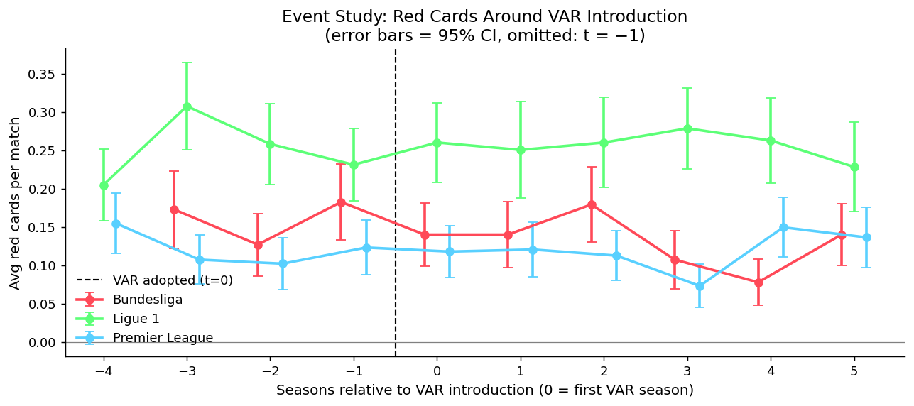
Figure 1: Event study looks at the average red cards per match by seasons relative to VAR introduction (t = 0 is the first VAR season). Error bars show 95% CIs. Flat pre-trends support the parallel-trends assumption.
4. Results
As seen in the Table 2 below, we see the VAR coefficient across four specifications. The pooled estimate is consistently positive across all models (suggesting VAR leads to slightly more red cards) but statistically insignificant. The preferred specification (Model 2) yields β_{VAR}= +0.014 additional red cards per match (SE=0.024, p=0.54), an 8% relative increase to the pre-VAR mean of 0.181. Point estimates are unchanged from league-clustered models; the larger SE with group level of N=98 (defined by team clusters) more accurately reflect the true sampling uncertainty.
Model | β_{VAR} | SE | p-value | N | Controls | FE
(1) TWFE - VAR only | 0.008 | 0.025 | 0.735 | 11,475 | No | Yes
(2) TWFE - VAR + controls | 0.014 | 0.024 | 0.543 | 11,475 | Yes | Yes
(3) +/- 3-season window | 0.014 | 0.024 | 0.578 | 7,360 | Yes | Yes
(4) Poisson MLE | 0.088 | 0.139 | 0.527 | 11,475 | Yes | Yes
Table 2: VAR coefficient across specifications. Outcome: red cards per match. Models 1-3 use OLS with SEs clustered at team level (N = 98). Model 4 reports Poisson log-coefficient (IRR = 1.092). Controls = total fouls and yellow cards per match. FE = home/away team FEs + season FEs.
The Poisson specification (Model 4) is appropriate given the count nature of red cards and heavy zero-inflation (~84% of matches). It gives an incidence ratio of 1.092, implying a 9.2% increase in expected red cards per match under VAR, though the estimate is also somewhat imprecise. The narrow-window robustness check (i.e. the Model #3) restricted to +/-3 seasons around each league's adoption date, yields the same point estimate, confirming the result is not driven by long-run trends in red card rates.
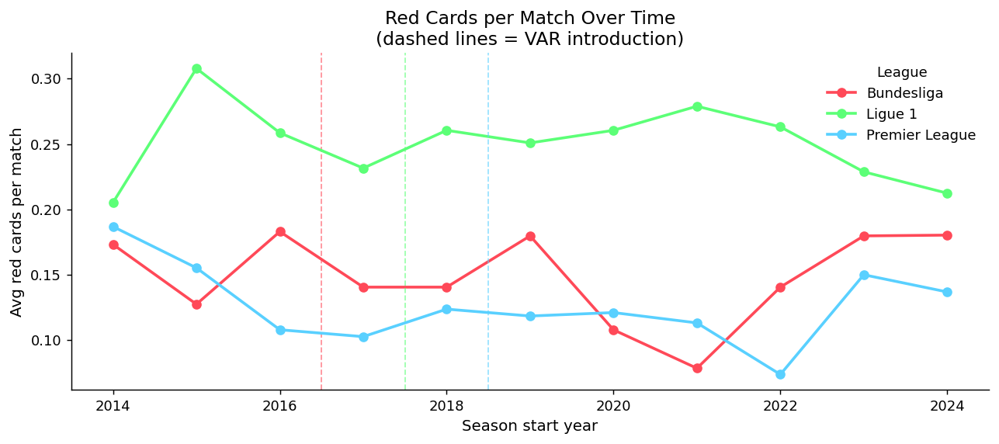
Figure 2: Average red cards per match by season. Dashed lines mark each league's VAR adoption. No sharp discontinuity is visible at adoption thresholds, consistent with a small and noisy treatment effect.
5. Discussion & Robustness
Does this show a causal effect?
Skeptics might argue that the estimates do not constitute convincing causal evidence for three reasons. First, even with 98 team clusters, the underlying treatment variation is at the league level (three units). This implies inference is effectively based on three independent policy shocks. Second, the parallel-trends assumption may not be formally tested with only three leagues. Finally, anticipation effects may bias estimates downward; if players and referees adjusted their behavior before VAR was formally introduced, the pre-period control is contaminated. Under this strict view, the results would be interpreted merely as a reduced-form association.
However, despite the limitations inherent in having only three treated clusters, the estimates provided can be credibly interpreted as a causal effect. The staggered rollout of VAR across the 2017, 2018, and 2019 seasons provides a robust defense against unobserved, time related global shocks. By using this staggered timing, the non-adopting leagues serve as a valid counterfactual at every stage. Furthermore, the event study shows significant flat and overlapping pre-treatment trends from t=-4 to t=-1. This empirically satisfies the main identifying assumption of DiD by showing that red card rates would have evolved similarly even without VAR. Finally, the threat of anticipation bias is reduced by the physical nature of the intervention. Players and referees cannot meaningfully adapt to (or simulate) video surveillance until the camera angles and the VAR are actively operating during a live match. Because the event study shows no pre-treatment divergence in the season immediately prior to adoption, anticipation can be reasonably ruled out as a source of bias.
The best way to have a cluster?
SE are clustered at the team level (N=98) rather than the league level (N=3). While I initially led with the league based cluster , however, with 3 clusters the yield was only df = 2 degrees of freedom for inference, making hypothesis testing unreliable. Thus, I changed it to Team-level clustering with N=98. This produced valid large-sample inference while capturing the dominant source of within-unit serial correlation (each team plays repeatedly across seasons).

Bad controls
If VAR changes refereeing such that fewer fouls are called because players behave more cautiously, including fouls as a control absorbs part of the causal pathway. Comparing Models 1 and 2 shows the VAR coefficient rises slightly when fouls and yellows are added (0.008 to 0.014), suggesting the pathway is small but cannot be fully ruled out.
6. Heterogeneity
The Figure 3 below shows league VAR effects from separate league OLS regressions with a linear time trend, home/away team FE, and HC1 robust SE. The direction of the VAR effect differs across leagues: the Bundesliga shows a negative estimate (β = -0.022, 95% CI between [-0.075, +0.030]), Ligue 1 a positive one (β = +0.031, 95% CI between [-0.032, +0.094]), and the Premier League is near zero (β = +0.005, 95% CI between [-0.042, +0.051]). All CIs include zero.
This heterogeneity is very informative. Ligue 1 has consistently the highest baseline red card rate (0.25 per match pre-VAR), suggesting referees there may be more responsive to VAR's prompts to upgrade decisions. The Bundesliga's negative estimate may reflect a deterrence effect, players behaving more cautiously under VAR surveillance or simply noise given the limited pre-VAR window. The PL has little change in behavior. These results motivate future work with more leagues and longer panels.

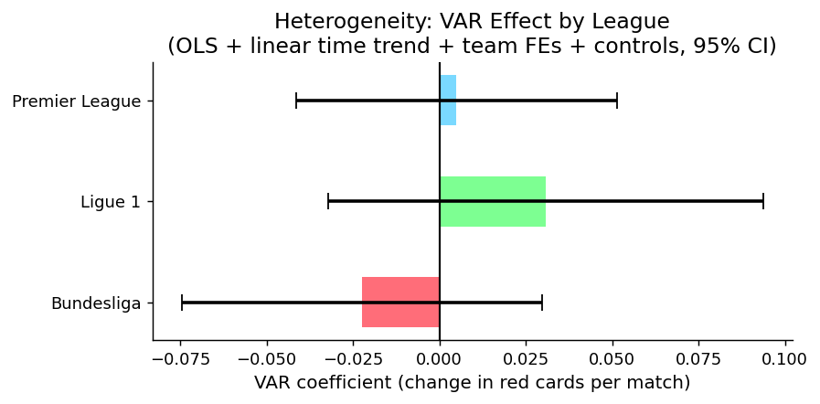
Figure 3: Per-league VAR coefficients with 95% CIs. OLS with linear time trend, home/away team FEs, HC1 robust SEs. All intervals include zero.
7. Conclusion
The question I sought to answer was whether VAR causally increases red cards in elite European football. Across four specifications (TWFE OLS, a narrow-window robustness check, and Poisson MLE) the pooled estimate is repeatedly positive (+0.014 red cards per match; IRR = 1.092) but statistically indistinguishable from zero. Standard errors clustered at the team level (N= 98) reflect within-team serial correlation; the underlying identification rests on three league-level policy shocks, and results should thus be carefully interpreted.
The heterogeneity results are the most informative finding: VAR's effect varies across leagues, with opposing signs for the Bundesliga and Ligue 1. This suggests the technology's impact is mediated by pre-existing refereeing culture rather than being a uniform mechanical effect.
The key policy take-away I see here is that governing bodies should not expect VAR to uniformly alter red card rates across all competitions. If reducing dismissals is a policy goal, VAR implementation should be paired with referee training calibrated to each league's baseline style and culture. The way I can expand the research limits and make it more informative would be through broader league coverage and longer pre-VAR panels as this would substantially improve identification.

